Pastry’s Performance Evaluation Report

This report describes and analyzes experimental results of the Pastry prototype implemented in JAVA. All experiments were performed on a PC with Intel(R) Core(TM) 2 Duo CPU (2.66GHz) and 2GB main memory, running Windows XP Professional version 2002 (Service Pack 2). The emulated network environment maintained distance information between Pastry nodes. Each Pastry node was assigned a location in a plane; coordinates in the plane were randomly assigned in the range [0,255]. Using the collected statistics, several basic performances of Pastry routing are evaluated as follows.

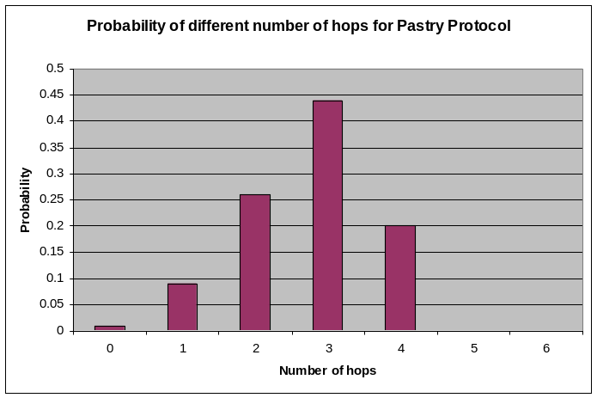
1. The first experiment shows the number of routing hops as a function of the size of the Pastry network. We varied the number of Pastry nodes from 2 to 256 in a network where b = 2, |L| = 4, and |M| = 4. For any given number of nodes, 100 trials were carried out. In each trial, two Pastry nodes were selected randomly and a message was routed between the pair using Pastry Protocol [1]. Figure 1 and Figure 2 show the results.
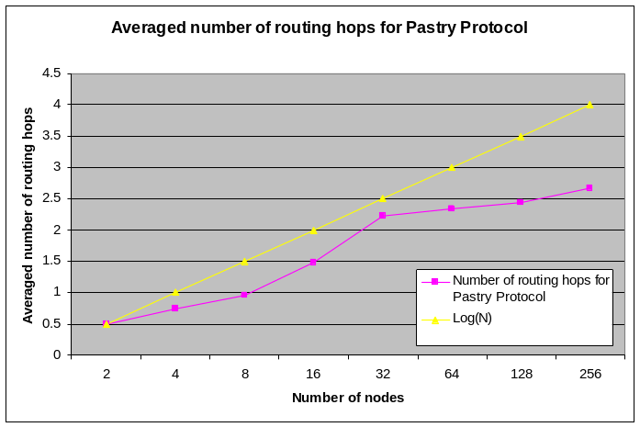
Figure 1: Average number of routing hops for different number of Pastry nodes, b = 2, |L| = 4, |M| = 4 and 100 lookups.
Figure 2: Probability of different number of routing hops, b = 2, |L| = 4, |M| = 4, N = 256 and 100 lookups.
Figure 1 shows the average number of routing hops, which is taken as a function of the network size. “Log (N)” shows the value log₂^{b}N and is included here for comparison (┌log₂^{b}N ┐ is the expected maximum number of hops required to route in a network containing N nodes). The result implies that the number of routing hops scales with the size of the network as predicted. Figure 2 shows the distribution of the number of routing hops taken for a network size 256, in the same experiment. The result shows that the maximum route length is┌ log₂^{b}N ┐ (┌log₂²256┐=4), as the theoretical analysis suggest.

2. The second experiment evaluates the locality properties of Pastry routes. It compares the relative distance a message travels using the Pastry Protocol, according to the proximity metric, with that of a fictitious routing scheme that maintains complete routing tables. The distance traveled is the sum of the distances between consecutive nodes encountered along the route in the emulated network. For the fictitious routing scheme, the distance traveled is simply the distance between the source and the destination node. The results are normalized to the distance traveled in the fictitious routing scheme. The goal of this experiment is to quantify the cost, in terms of distance traveled in the proximity space, of maintaining only small routing tables in Pastry. Figure 3 illustrates the result, from which we can conclude that except some noisy points (like the case of 64 nodes), the Pastry routes are only 20%-30% longer for most cases, and some are about 100% longer (like the cases for node number 128 and 256).

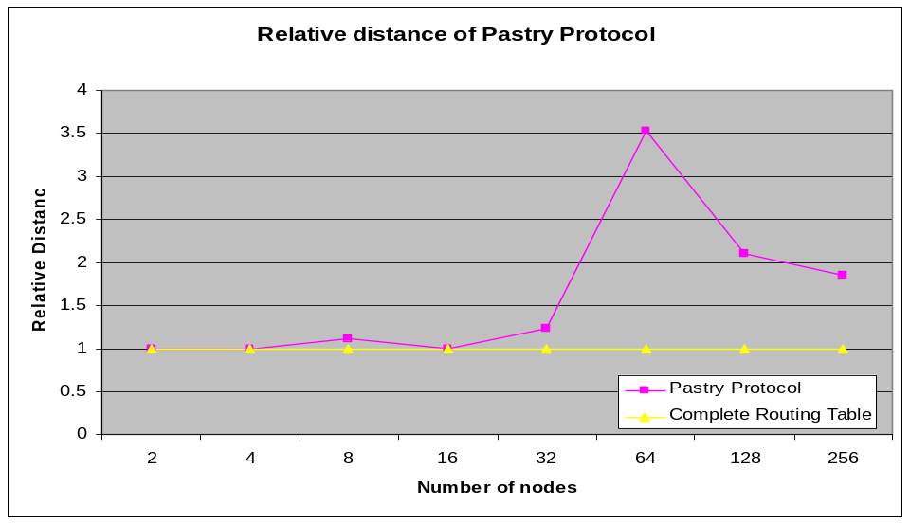

Figure 3: Relative route distance for different number of Pastry nodes, b = 2, |L| = 4, |M| = 4, and 100 lookups.

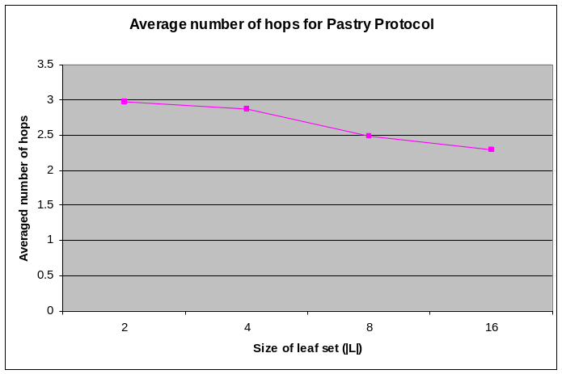
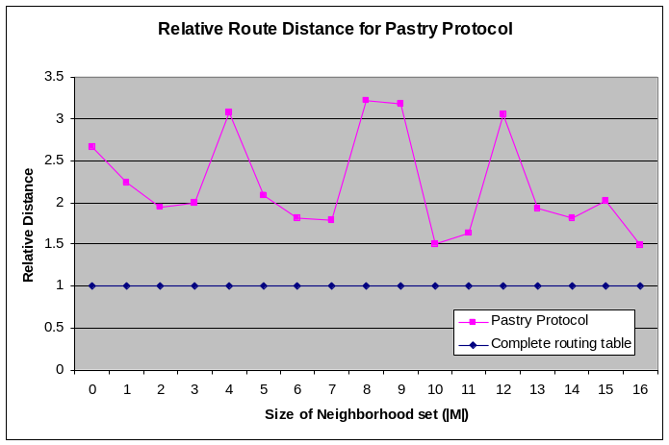
3. The third experiment evaluates the average number of hops for different size of leaf set |L|. With b = 2, |M| = 4 and N = 256, we varied the size of leaf set from 2 to 16 and got the corresponding results shown in Figure 4. It can be seen from the figure that the average number of routing hops drops as the size of leaf set (|L|) becomes larger, as expected.
Figure 4: Average number of hops for different size of leaf set (|L|), b = 2, |M| = 4, N = 256 and 100 lookups.
Figure 5: Relative route distance for different size of neighborhood set (|M|), b = 2, |L| = 4, N = 128 and 100 lookups.
4. The fourth experiment evaluates the route distance for different size of neighborhood set |M|. With b = 2, |L| = 4 and N = 128, we varied the size of neighborhood set from 0 to 16 and got the corresponding results as shown in Figure 5. The result implies that the route distance has no direct relation with the size of neighborhood set (|M|).

Reference:

[1] A. Rowstron and P. Druschel, "Pastry: Scalable, distributed object location and routing for large-scale peer-to-peer systems," 2001, pp. 329-350.

